

**CLOUD COMPUTING**

**LAB:03**

**Submitted By:**

Seerat Fatima

**Registration.no:**

2023-BSE-060

**Section:**

5B

**Submitted To:**

Engr.Shoaib

**Task 1 – Handling Local and Remote Commit Conflicts (Pull vs Pull --rebase)**

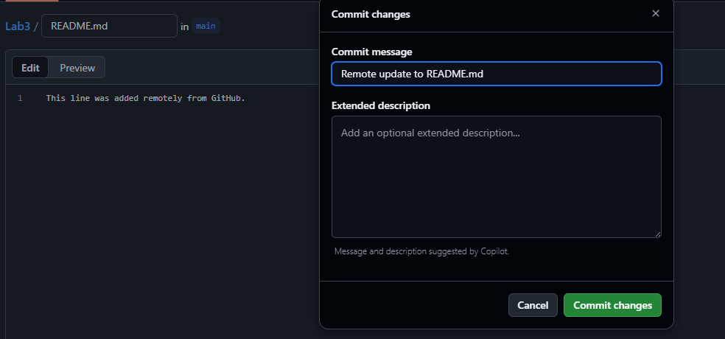

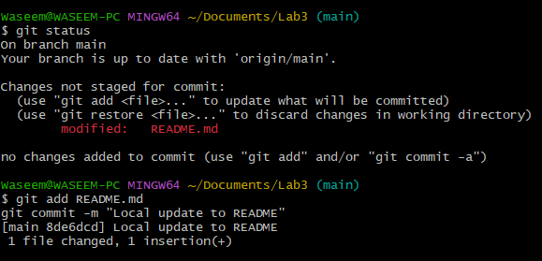

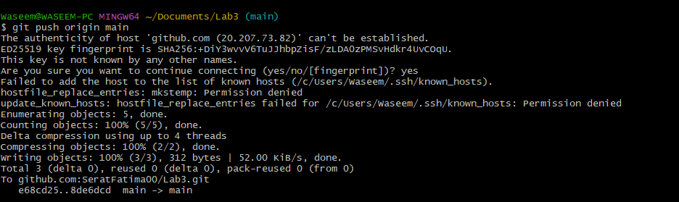

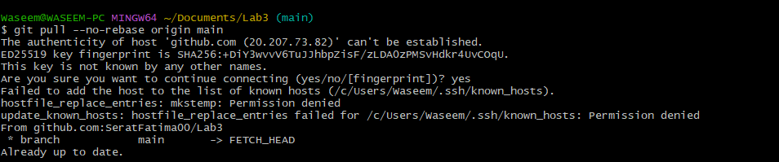

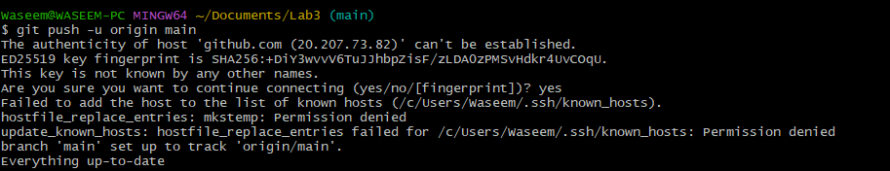

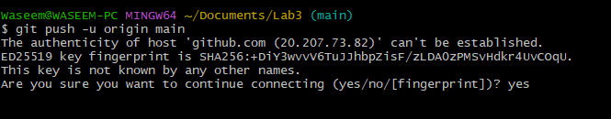

**Task 2 – Creating and Resolving Merge Conflicts Manually**

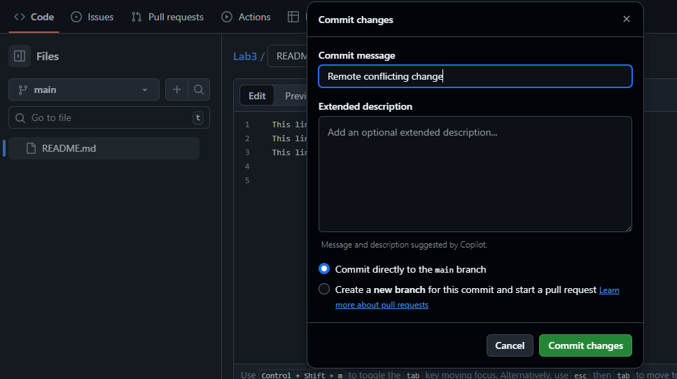

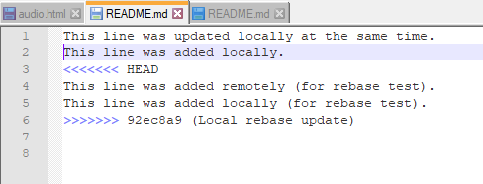

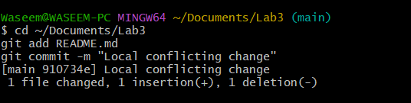

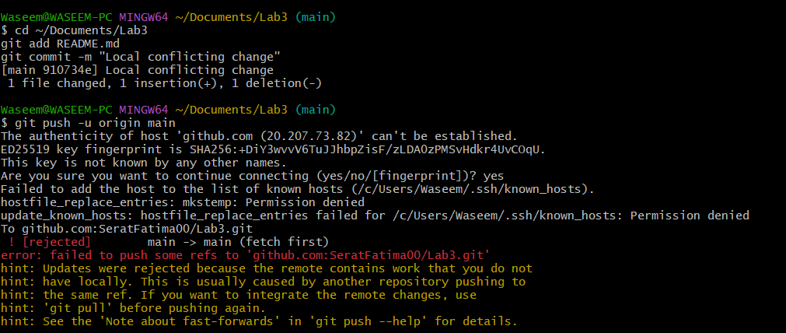

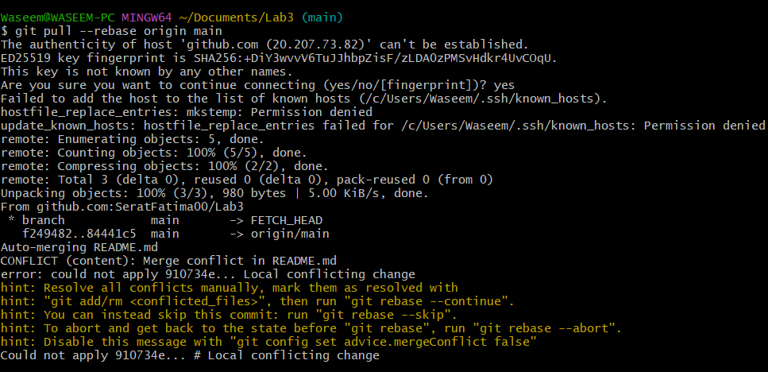

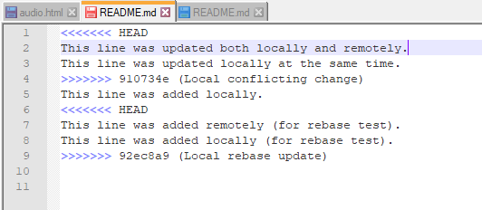

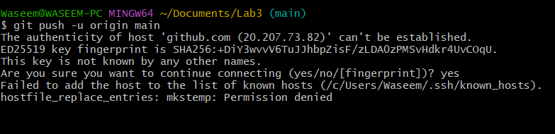

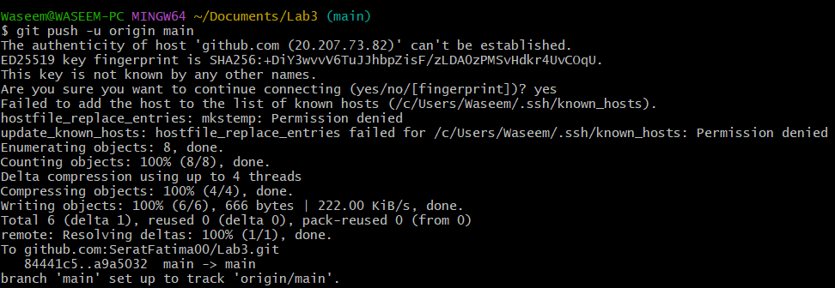

**Task 3 – Managing Ignored Files with .gitignore and Removing Tracked Files**

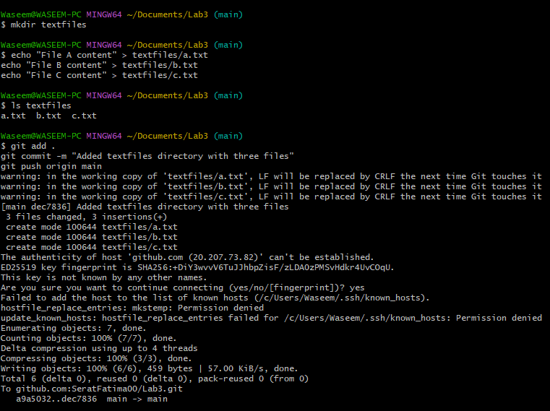

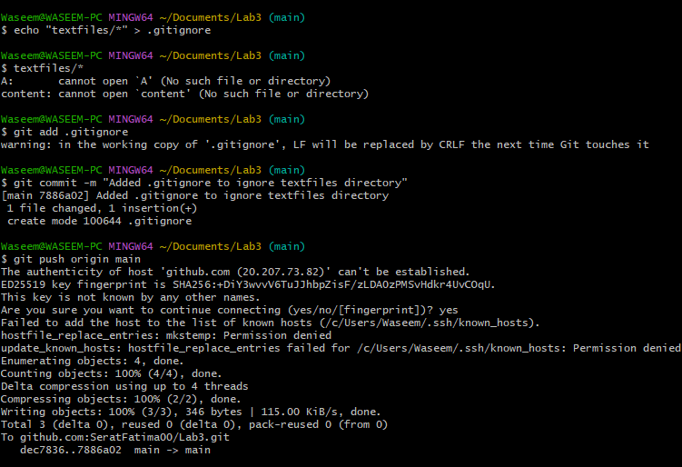

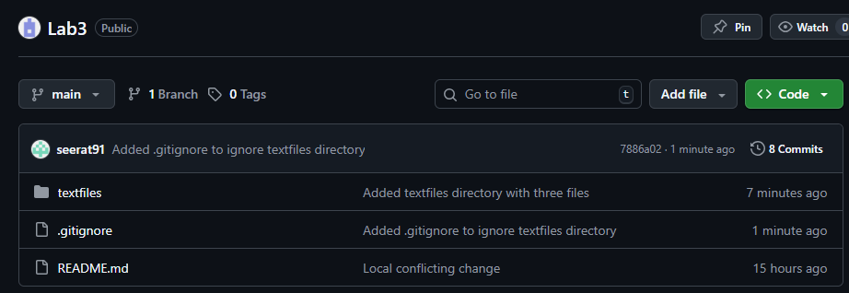

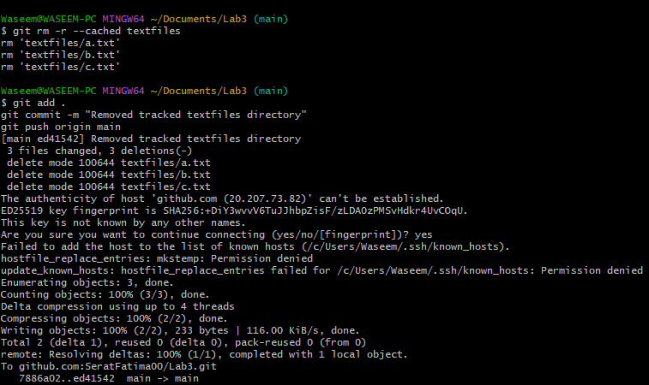

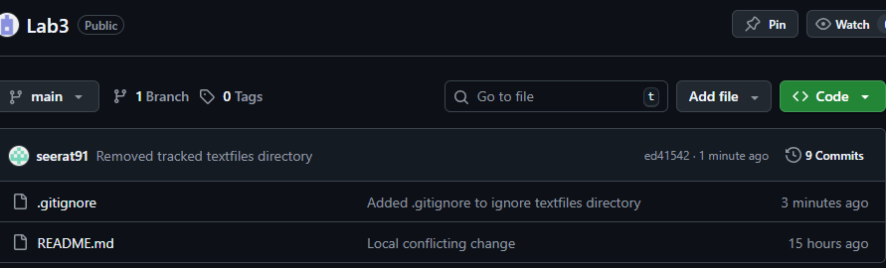

**Task 4 – Create Temporary Changes and Use git stash**

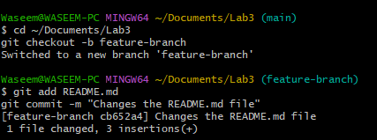

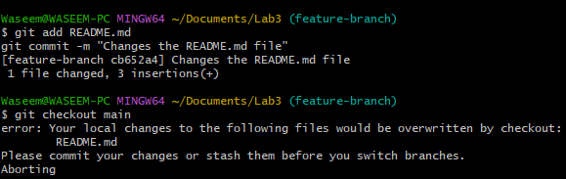



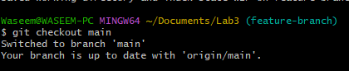

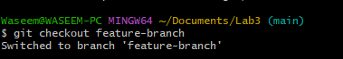

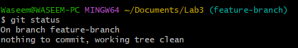

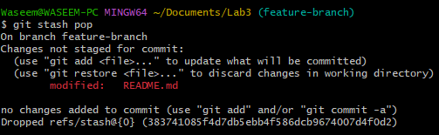

**Task 5 – Checkout a Specific Commit Using git log**

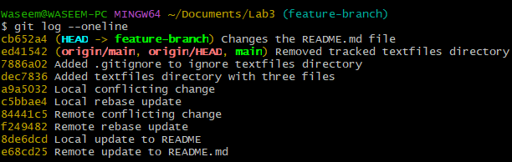

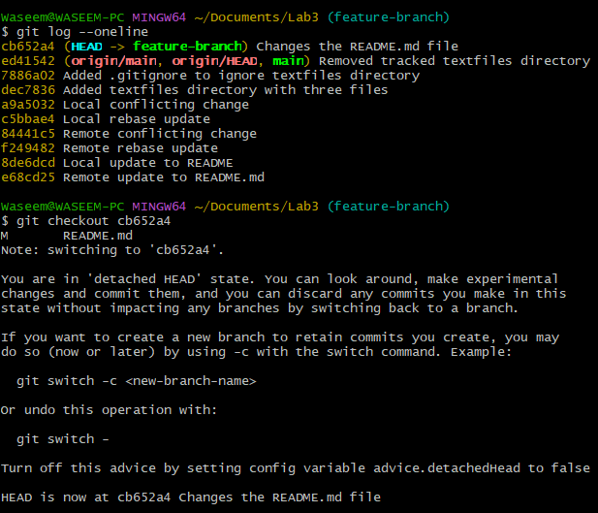

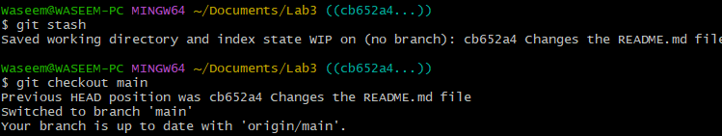

**Task 6 – Resetting Commits (Soft vs Hard Reset) (With Verification Steps)**

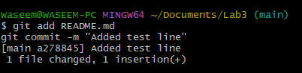

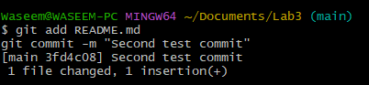

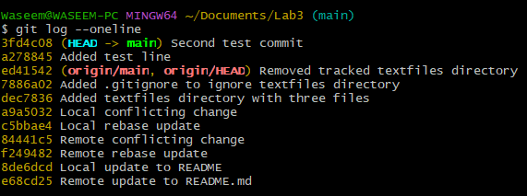



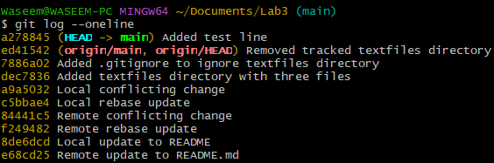

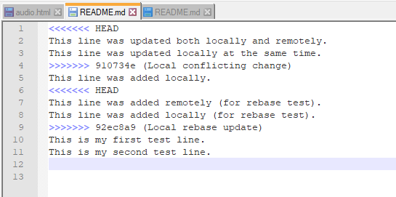

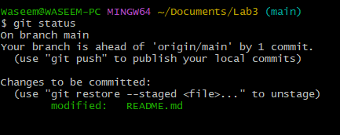



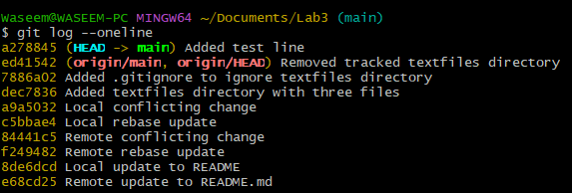

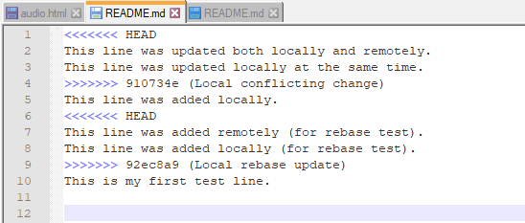

**Task 7 – Amending the Last Commit**

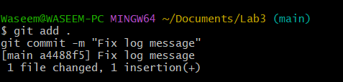

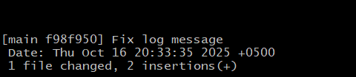

**Task 8 – Reverting a Commit (Safe Undo on Remote Branch)**

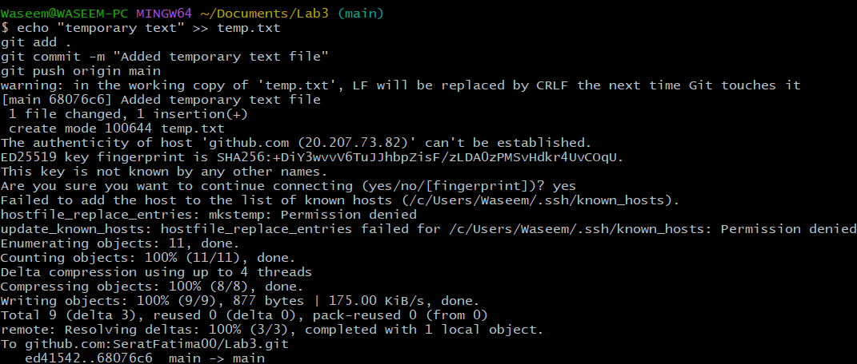

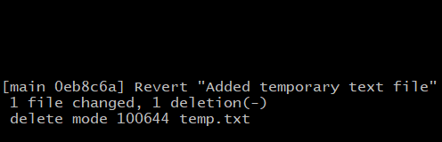

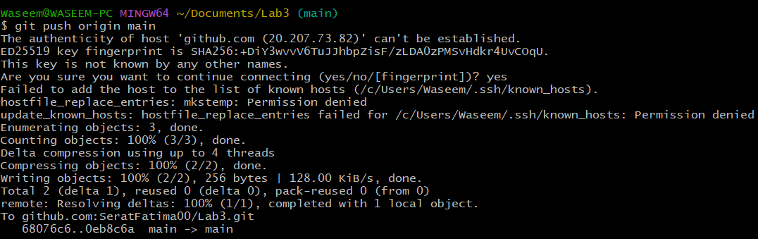

**Task 9 – Force Push (With Caution)**

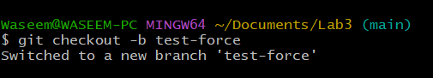

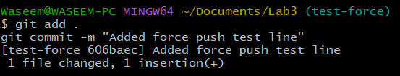

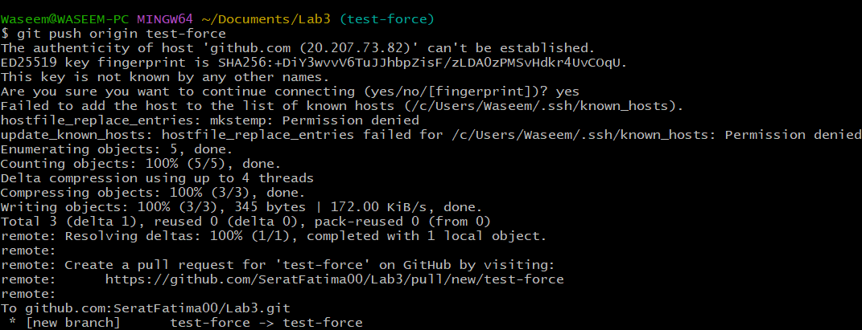

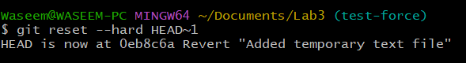

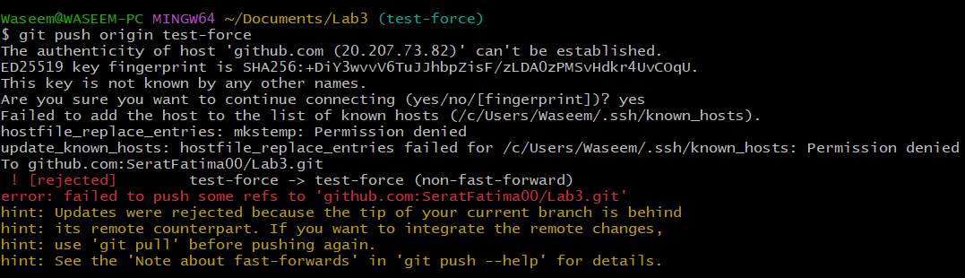

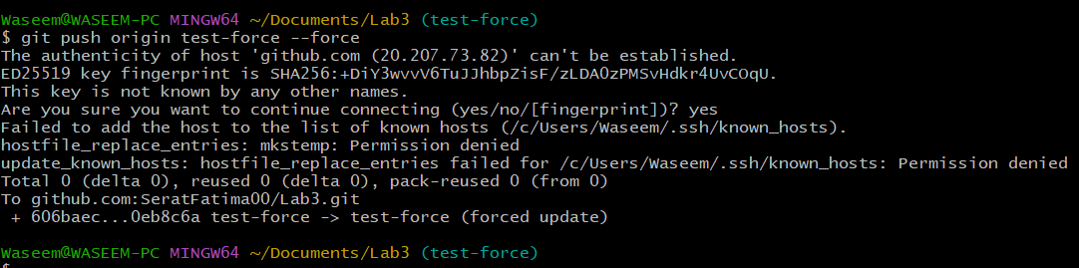

**Task 10 – Running Gitea in GitHub Codespaces via Docker Compose**

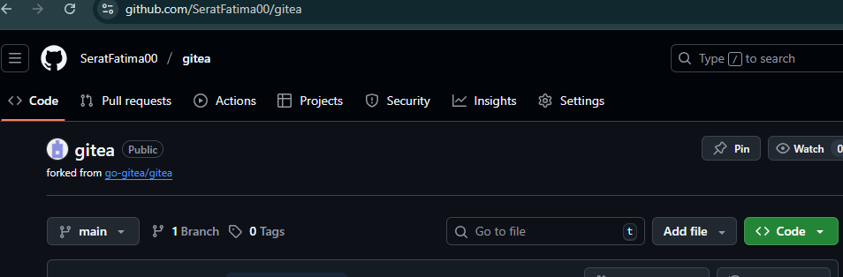

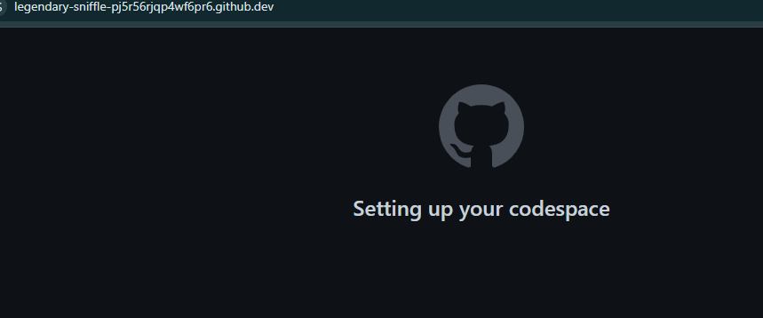

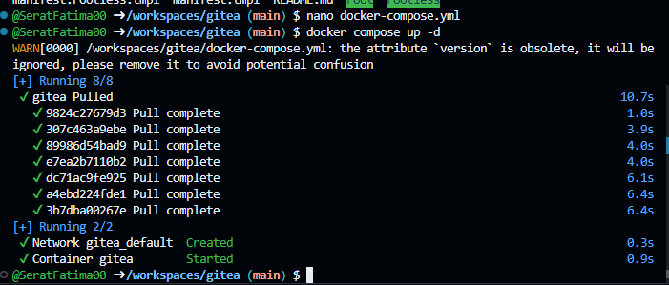

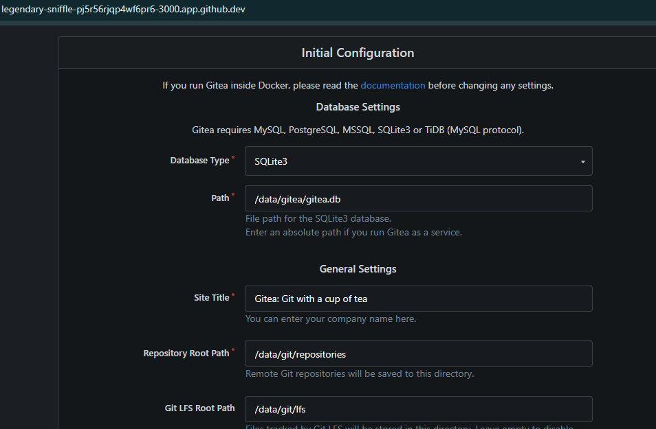

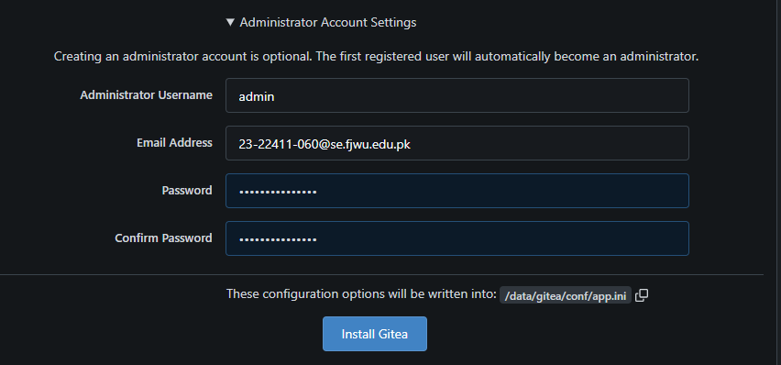

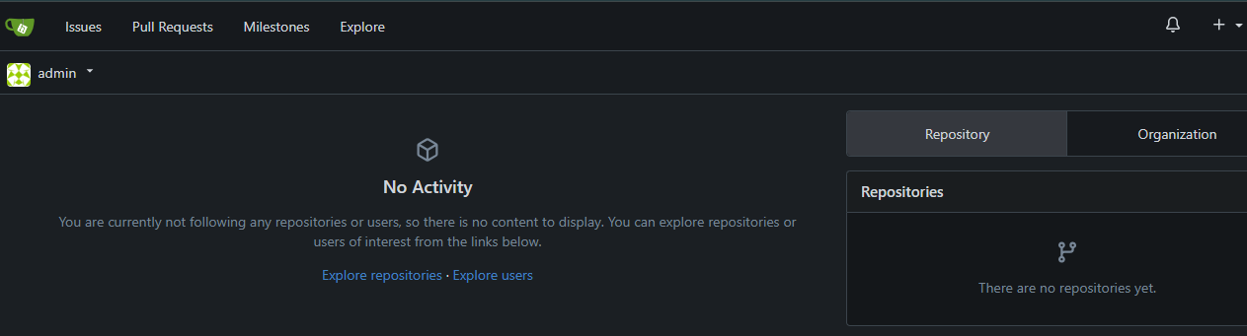

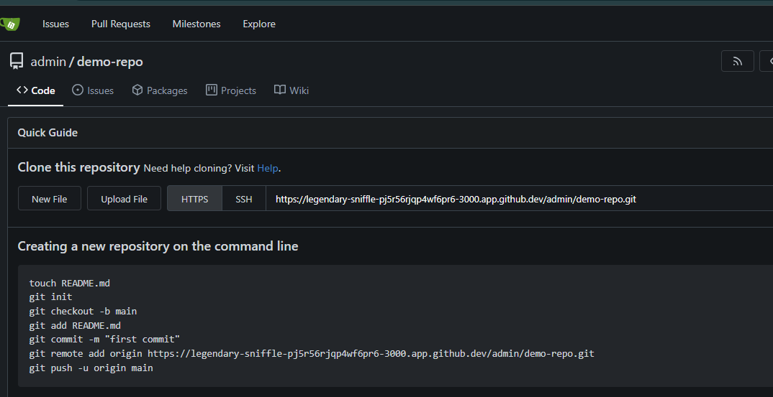

**Task 11 – Creating a GitHub Pages Portfolio Site**

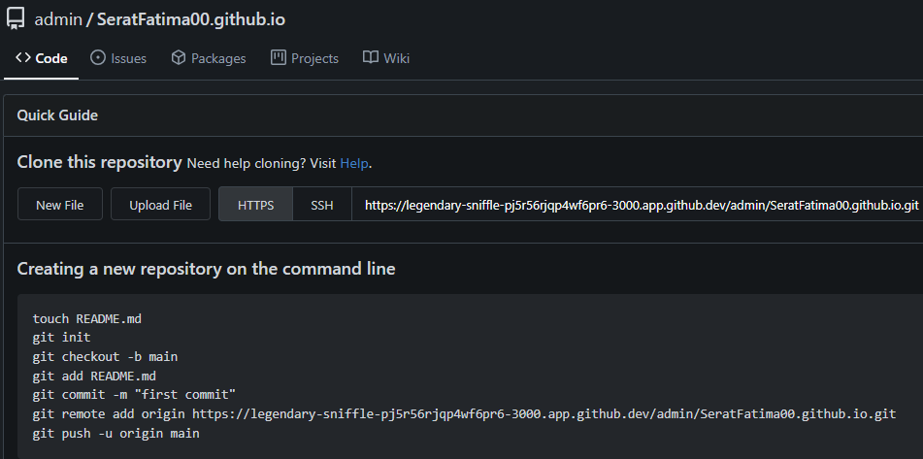

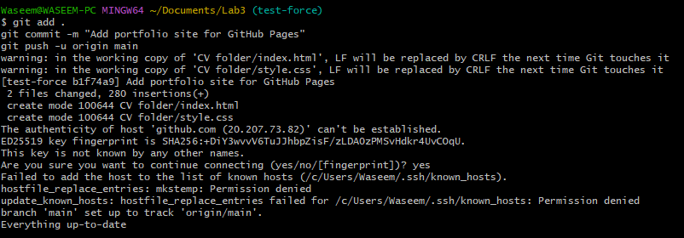

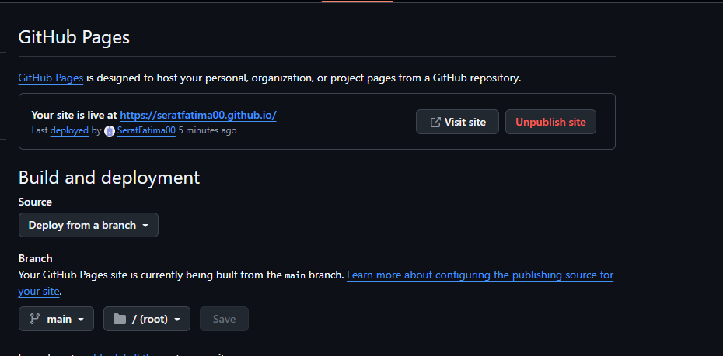

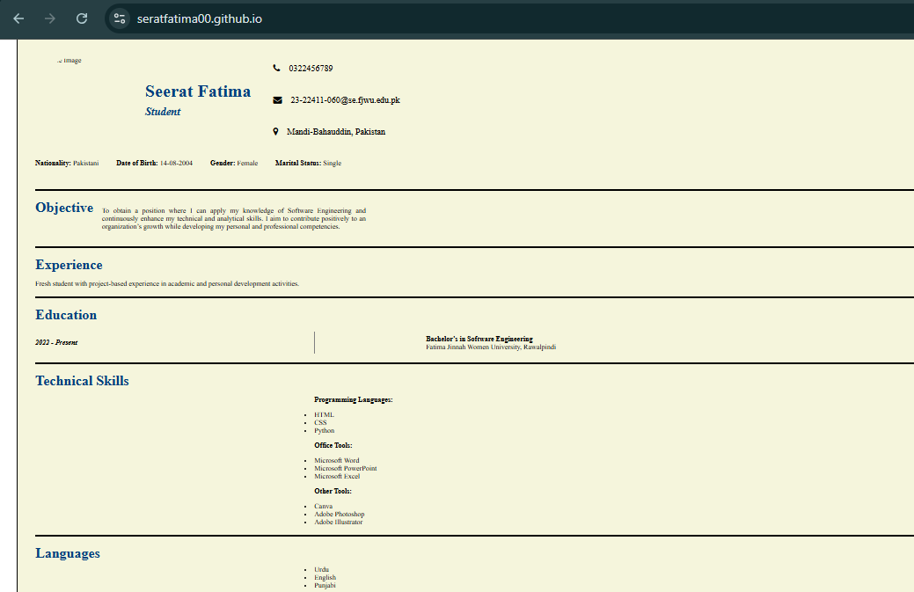

**Exam Evaluation Questions**

**1. Local vs Remote Conflict Resolution**

**Steps:**

1. On GitHub, edit a file (e.g., README.md) and commit the change.
   * Screenshot as Q1_remote_edit.png
2. On your local machine, edit the same file differently (Avoid Conflict) and commit.
   * Screenshot as Q1_local_edit.png
3. Try to push your local commit and observe the error.
   * Screenshot as Q1_push_error.png
4. Resolve the conflict by running git pull (merge), then push.
   * Screenshot as Q1_merge_resolution.png
5. Repeat with another remote/local change, but resolve using git pull --rebase, then push.
   * Screenshot as Q1_rebase_resolution.png

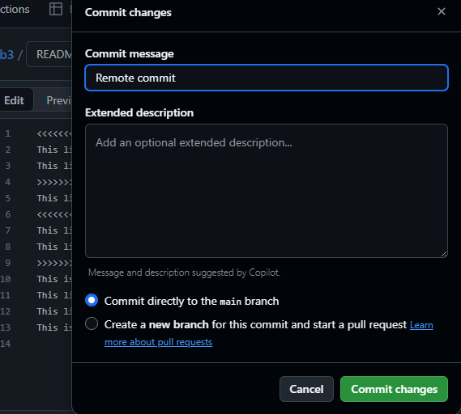

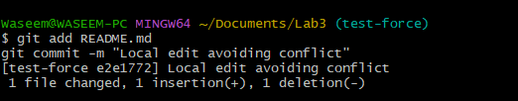

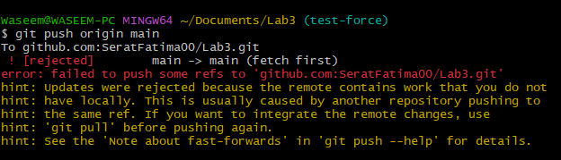

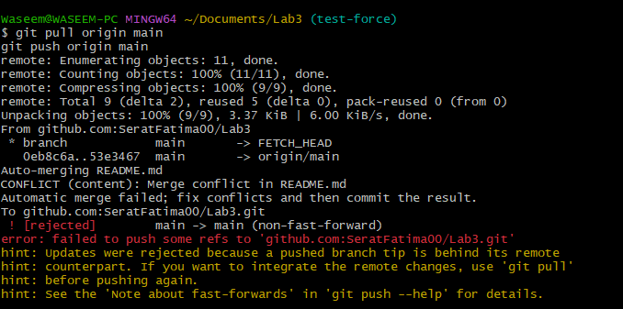

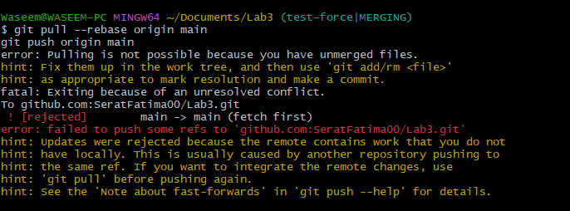

**2. Manual Merge Conflict Handling**

**Steps:**

1. On GitHub, change a specific line in a file and commit.
   * Screenshot as Q2_remote_conflict_edit.png
2. Locally, change the same line differently and commit.
   * Screenshot as Q2_local_conflict_edit.png
3. Try to push your local change and observe the conflict error.
   * Screenshot as Q2_conflict_push_error.png
4. Use git pull --rebase to fetch changes and trigger the conflict.
   * Screenshot as Q2_rebase_conflict.png
5. Edit the conflicted file to resolve the conflict manually.
   * Screenshot as Q2_resolved_file.png
6. Mark the conflict resolved (git add <file>, git rebase --continue) and push.
   * Screenshot as Q2_resolution_complete.png

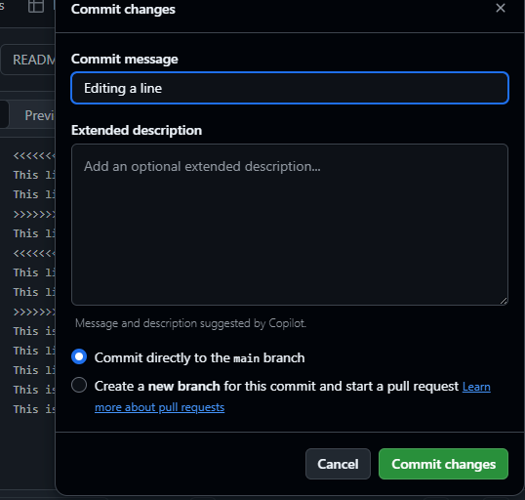

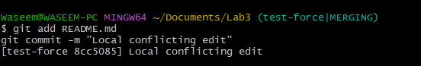

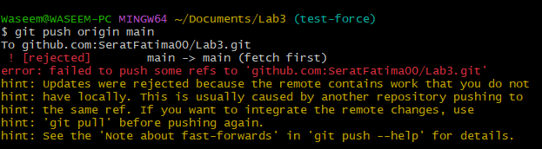

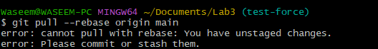

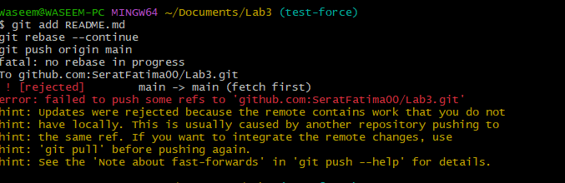

**3. Managing Ignored and Tracked Files**

**Steps:**

1. Create a new folder (e.g., DocFiles) and add several files inside.
   * Screenshot as Q3_folder_created.png
2. Commit and push the folder/files to GitHub.
   * Screenshot as Q3_files_pushed.png
3. Add the folder to your .gitignore file.
   * Screenshot as Q3_gitignore_added.png
4. Commit and push the .gitignore update.
   * Screenshot as Q3_gitignore_pushed.png
5. Remove the folder from tracking using git rm -r --cached <folder>.
   * Screenshot as Q3_folder_untracked.png
6. Commit and push the change, then verify the folder is no longer tracked on GitHub.
   * Screenshot as Q3_folder_removed_github.png



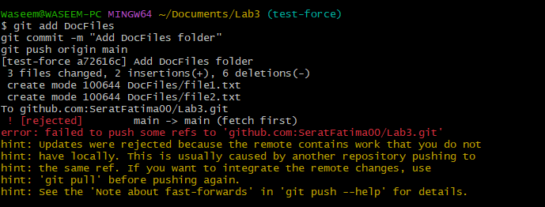

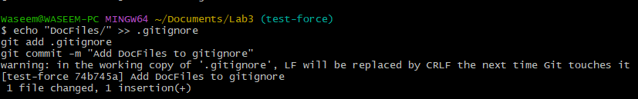

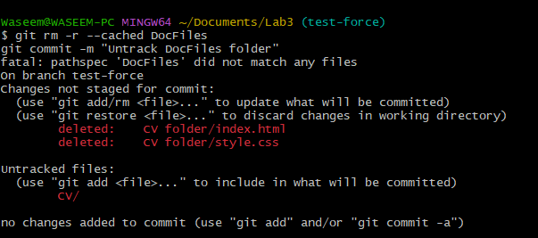

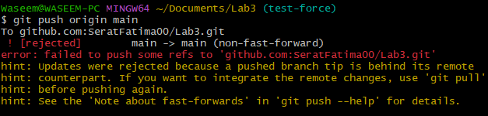

**4. Commit History Manipulation and Recovery**

**Steps:**

1. Make a change and commit it.
   * Screenshot as Q4_first_commit.png
2. Make another change and commit again.
   * Screenshot as Q4_second_commit.png
3. View your commit history.
   * Screenshot as Q4_commit_history.png
4. Perform a soft reset (git reset --soft HEAD~1) and observe your file and history.
   * Screenshot as Q4_soft_reset.png
5. Make commit again.
   * Screenshot as Q4_third_commit.png
6. Perform a hard reset (git reset --hard HEAD~1) and observe the changes.
   * Screenshot as Q4_hard_reset.png

